ANNUAL REVIEW | 1

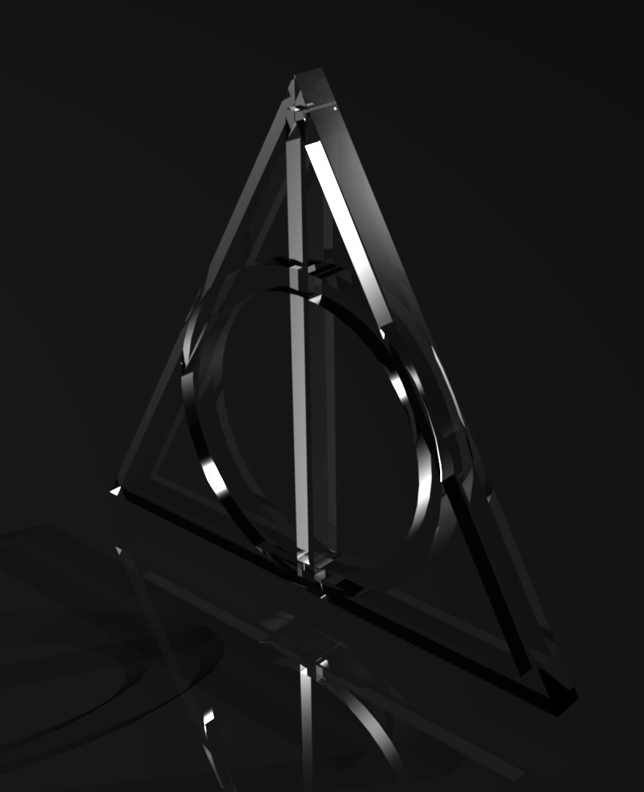

|  |
| --- |
| JOURNEY TO |
| **THE TRIANGLE** |
| ABANI BHUSAN DAS |

Table of Contents

Introduction 3

PLOT 4

Chapter 1 5

Chapter 2 7

Chapter 3 9

Chapter 4 10

Chapter 5 12

Chapter 6 13

JOURNEY TO: THE TRIANGLE

This is a tale about two young scientists for whom scientific discoveries were much more important than their own lives. Set on a Mysterious Island where a group of scientists went to find their missing friend.

But the stuff they found on that wretched island scarred them for their entire lives.

The Triangle is an adventure game with mind boggling puzzles and mysteries which one have never heard. An epic tale of friendship, betrayal, love and honor.

An epic storyline to give you company.

Solve the secrets of the island, find your missing friends and escape.

But can you escape this Hellhole.

A Story with many figurines Dr. Jane Horace

World renowned Physicist who believed she had uncovered the secrets of the triangle.

Dr. Edward Finlay

Jane’s love interest and he worked with Jane on the triangle for seven years. Lot of time

Mr. Jason Hudson

A MIT graduated engineer who had worked with lasers and is fascinated about lights

Nathan and Hunter

Two interns who works under Finlay and decided to tag along to find their missing teacher

An Engaging Storyline Challenging Puzzles Memorable Characters Addictive Mini Games Heightened Drama

A Long-Lost Mystery

THE MYSTERY IS NOW SOLVED BUT AT WHAT COST PLAY THE GAME

GET ANSWERS

# Plot

“This is a story of survival. A story of responsibility, A story of belief and a story one had never heard. I’m Edward, Dr. Edward Finlay. Since there are no camera around us anymore, I shall tell you what really happened on Bermuda.

It was August 23rd 2048, I was in charge of five interns who had the same topic of interest, The Bermuda Triangle. Since the last 60-70 years people have been studying the strange phenomenon attached to the Triangle. Why planes and ships were lost and never found, why compass behaves strange particularly at that place, just what is this place.

Many theories suggested, something paranormal was going on. But we as scientists we never believed in something of that sort. Dr Horace and I have been working on this for the past seven years, and we had finally cracked down the entire thing, or at least we thought we had. If you guys are wondering if anything paranormal was going on then please don’t get your hopes up. No, there was nothing of that sort.

It was far worse than that.

Dr. Horace went to the HOD of the research department to ask for a plane so that she could fly down to the island Black Cup which was right in the middle of The Triangle as she believed that island was the key to the Mystery which was unsolved for decades. It was named after the pirate ship Black Pearl which sank near that island. Her theories and equations were spot on and she said she knew how to reach that island. According to her, that was the very first piece of matter which was created after the Earth was formed.

She was denied access to jets. Even though her theories were correct, the risks were still high. It was still the devil’s triangle.

She believed she was onto something, something big. She believed she could solve string theory as well and uncover the origin of the universe. The look on her face was something. She was very much confident.

What we did next was the beginning of a big change. A massive scientific achievement which changed the way of physics forever. But has scarred us. The guilt we carry is far bigger than this achievement.

CHAPTER ONE

Beginning Of the End

Later that night, Dr Horace came to my office. She was furious as she was denied flying down to the island.

HORACE: - “Edward, I’m telling you, Black Cup is the key. If my theories are correct. We could solve the meaning of life. We could solve the theories of black holes and in continuation. String theory.

EDWARD:- “Jane, there is still an If in the mix, we can’t just fix everything on an if. We need concrete evidence. Do we have that. Jane we would be putting our team in a lot of jeopardy.

HORACE:- “That is the reason why, I need to go there, the only way to prove the Department that I can take everyone to the Black Cup is by going there myself. Edward, I know you have the keys to the hanger. I’m practically begging you. Let me go.

EDWARD:- “Jane, I know this is your life’s work. You’ve spent too much time on it. Hell, even I had spent seven years with you proving these theories with you. I know how important it is to you cause its important to me as well. We have two teams filled with young talents to lead. Jane, think. What if all this goes wrong. Department would lose millions and a world-renowned scientist. These young lads will lose a leader.

HORACE:- “But I am telling you, I can take you there, Edward, believe in me. For old times’ sake”.

EDWARD:- “Jane, the answer is still no. The risks are still high. You can leave now; we will discuss it in the morning” HORACE:- “Edward, please you…..”

EDWARD:- “Jane, Leave… Now”

Dr. Horace leaves my cabin. She was furious. The department had scraped off something she was working for 10 years now. It was sad to see her like that. But everything changed when she took this matter onto her own hands.

(Dr. Jane Horace went back to her cabin and was racing nervously in there)

HORACE:- “Why Edward, after all these years, you still don’t believe in me.. Urrggh Edward, I hate you… I need to act fast now. Wait, that’s it, Edward keeps the hanger codes in his office, I can sneak in at night. Sorry Edward, I have to do this”

GAMEPLAY

You play as Dr. Jane Horace now, explore her room and find her keycard. Her keycard is to be found on her left desk drawer. The missing knob can be found under her bed. After attaching the knob and opening the drawer, her keycard is kept inside a Japanese Puzzle Box.

Solve the pattern matching puzzle Get The keycard.

You need to cut the camera access to cover up your tracks. Move towards the security room and get in. The computer is password protected. Dr Horace goes back to her room to find her virus loaded USB Flash Drive which is found on her make up box located at the top shelf of her cupboard.

Connect the USB Drive to the computer. Play a minigame, of allowing a worm to crawl through pipes and eat the bug. Basically, it is a visual representation of how worm infect computer.

After getting access to the computer Disable the security cameras.

Now, Doctor Horace has to go to her cabin to get her camera a portable wireless device which acts as a hotspot and can pull signal from her office, one half of a Walkie Talkie and her papers. You can find Dr. Edward’s stuff as well in her office which acts as clues for later.

This includes his driver’s license, his citizenship card and a bag with all his daily essential like comb.

Dr, Horace now needs to get into Dr. Edward’s office but to get into his office. His office is biometric protected which need Dr. Edward’s DNA signature to get into it.

You have Dr. Edward’s come, retrieve a hair from his comb, look under the electronic microscope and retrieve a pattern. That pattern is Edward’s office biometric lock’s code.

Get into Edward’s office, The Hangar codes are on his computer.

(Clue, Edward’s Wallpaper is a Picture of Him and Dr Horace when they received the MacArthur Grant, Edward has feelings for Doctor Horace hence the wallpaper).

The Hangar Code are on a lockbox application on the computer. There is a Hitchhiker Guide to The Galaxy book present on the desk. According to the guide, the number 42 is the answer of everything. 42 is a crucial numberand will be used later.

The code of the lockbox is 42. Retrieve the Hangar codes.

Get outside of the building and move towards the hangar. Open the hangar by putting the code in the biometric lock. Attach the fuel line to the jet, check the engine.

Get inside the jet. Solve a correct order puzzle in order or start the engine.

1. Fuel Injection
2. Safeties On.
3. Close the Glass
4. Start the engine
5. Fly Away.

CHAPTER TWO: -

Missing

Dr. Horace before leaving had left one half of her Walkie Talkie with Dr. Edward at 5:30 in the morning Dr. Edward gets static noise form his Walkie Talkie and wakes up.

Walkie Talkie works on frequencies and since Dr. Horace has gone to a strange place. The frequency varied a lot. Find the correct frequency by using the dial given in the walkie talkie and listen closely.

After tuning in.

HORACE: - Horace to Edward (static….) Horace To Edward…. How Copy… Over (static….) EDWARD: - This is Edward…. How Copy…. Over

HORACE: - Ed…. I have made it… I am on the Black Cup…. EDWARD: - What…. How did you… I mean… what…

HORACE: - Listen closely Ed. For all these years we were wrong, there was nothing supernatural going on here, everything over here is (Line breaks)

EDWARD: - Hello…. Hello… Jane are you there…. “What have you done Jane”

Announcement “Dr. Jane Horace have gone missing; I repeat Dr. Jane Horace have gone missing in the triangle after she took an aircraft from the Hanger last night…. For everyone’s safety, no one is going for a rescue mission, and we declare Dr. Horace MIA and presumably…. Dead. It’s a sad day for everyone and for science”

Jason Hudson is Edward’s friend and works on lasers.

EDWARD: - “Hudson, I have something really Important to tell you”

JASON: - “I know what you are thinking Eddie, but no, we cannot go issue a rescue mission”. EDWARD: - “No, that’s not the only thing I’m going to talk about here”.

Edward shows, the walkie talkie and shows him the recording. JASON: - “My god Ed, she still out there, we have to go save her”

EDWARD: - “Yes, she was right all along, we need to see how she flew down there”

JASON: - “Make a team Ed, I’ll take care of the necessary stuff. Meet me at the Hangar within fifteen minutes”

Search areas and gather clues on how Jane went inside the triangle.

Get inside Jane’s office. Her office is locked and it has biometric authentication and needs her fingerprint. Check the security footage to know what all did she touch.

EDWARD: - “Oh my god Jane, you definitely are smart but I am smarter did you forget that I am the one who made that virus. It keeps backup, I believe the backup files are created with a password generated folder”.

Open the USB Drive, you’ll find a clue which contains the password.

Has a mouth, but cannot drink. Has a head,

but cannot think. Has a tongue, but not a lung.

Some are held

and some are hung Answer: - Bell

Check the footages where you can find Jane’s fingerprints.

Her fingerprints were on the doors of both the labs, and on the soda machine button and the soda can on the bin.

Take Scotch Tape and Scissors from the server room and retrieve the fingerprints from the soda machine, the can and the doors of each lab.

After retrieving the four fingerprint samples take them to your lab to check which ones can be used properly.

Fabricate jane’s fingerprint on a rubber thumb using Lasers which is a rearranging puzzle and the result is a rubber thumb with Jane’s fingerprint.

Use this to get inside Jane’s lab.

Find her papers and solve this to know at what speed and at what altitude should the jet travel so that you could land safely.

3x+y=7 and 3x+2y=8

Where x’s value is the speed and y’s value* 100 are the altitude. Solve this equation in order to put the values in the jet to take off.

Get your team ready, the Team comprises of Edward, Jason, Nathan Reyes and Hunter Bradley. The later two are two of your most successfulinterns

Get towards the Hanger, use the code found on the first chapter to open the hangar. Jason and the rest of the team arrives.

EDWARD: - “Nate… Hunter, you two one of a kind of your generation… I don’t exactly know what the risks are… But there is no one else who could do this except you two. But, if you want to back out, its completely understandable”.

NATHAN: - “Dr. Horace is our teacher as well Dr. Finlay, and we are going to find her.”

HUNTER: - “And besides, the only one who could fly a bird like that is me… Lets go get our teacher back”

CHAPTER 3

Into The Storm

You play as Hunter now.

HUNTER: - “Dr. Finlay, the altitude….”

Enter the value of x and y found in the previous chapter to start the plane and fly off

EDWARD: - “Okay Hunter, keep the bird steady at that speed and that altitude, we will be there shortly, and keep it steady”.

Keep the line steady minigame.

Two sticks are given, which are left to right and up to down. You need to keep the green line overlapping with the red line in order to fly properly or else it’ll crash. The green line will get obstructed and will change because of the air resistance.

EDWARD: - “Nate, try finding Jane’s signal on the radar. Get the stronger signal, the last I saw it was coming from the North East direction”

Hit and Trial

There are 16 squared tiles among which one has the signal of Jane Horace’s Walkie Talkie… But you get only six chances to do that.

HUNTER: - “Oh No…”

EDWARD: - “What is it”

HUNTER: - “Waterspout… we need to get off the bird…” EDWARD: - “What… are you insane, we will die” HUNTER: - “If we don’t, we will die, look…

EDWARD: - “Is that… is that it”

HUNTER: - “Yes, it’s the black cup and look it’s our aircraft landed…” JASON: - “Must be the one Horace took”

HUNTER: - “We need to jump; I am opening the rear end”

Memory game

There are three buttons with red, green and orange light, match the sequence in which the lights appear in the given time of ten seconds to open the rear exit.

HUNTER: - “Everyone… JUMP!!!” Rearranging Game (x3)

Rearrange the given pictorial puzzle to pull the chute’s trigger. The first puzzle should be solved with 30 sec.

Next will be 20 Final will be 15

Everyone jumped all together but the wind drifted them away, the plane crashed onto the island, but luckily, everyone took all their belongings with them landed safely. Except Hunter, that boy, he couldn’t get out.

CHAPTER 4 STRANDED

You Play as Nate now who landed near the Horace’s jet.

NATE: - (Screaming) “Hey…. Can somebody hear me, Edward, Jason, Hunter…? Can anybody hear me… Please”

NATE: - (To Himself) “it’s sunny outside by why is it so damn cold out here, I need to start a fire somehow it’s so damn cold. I should check the temperature and the coordinates as well.

Check using the satellite phone Nate has

NATE: - (To Himself) “I need to get inside Horace’s jet. Damn it, what’s the password, wish Hunter was here. Puzzle

The password to Horace’s jet is the coordinates of the Island Open the jet

Collect items which can start a fire, such as twigs, logs and leaves not papers because we cannot burn research papers.

Use the jet fuel.

Use magnifying glass found inside Horace’s jet to lit a fire. A bottle to collect Jet Fuel

Scissors A Bowl

There are MRE’s in the jet as well, use them as food. Find a spot,

Arrange the twigs leaves and logs,

Douse them with the fuel and using the magnifying glass to light the fire. NATE: - (To Himself) “That’s much better… Right… Food”

Puzzle

Open the MRE’s using scissors found on Horace’s jet

Inside the MRE the is a picture depicting how to prepare the meal. First, get water

Add the spice packet onto the water Add the flavoured oil into the water. Bring it to a boil.

Pour the food inside the water and cook it till water evaporates. Enjoy The Meal.

???: - (Static) “Can anybody hear me… (static)…. Can any (static)…. (Line Breaks).

NATE: - “Yes… I Can Hear you…. Yes…. Hello…. Who is it…? NATE (To Himself): - It needs adjustment

Puzzle

Adjust the frequency and find the correct channel from which the signal was coming from among different channels within the given amount of time.

NATE: - “Am I audible, how copy… over:

???: - “Is that you Nate”

NATE: - “Who is this… over.

???: - “It’s me, Jason”

JASON: - “Listen closely kid, I have found a cave like structure. It looks like some kind of Shrine and it’s written in Mandarin, trace my location somehow and get here. I know you can translate this.

NATE: - “I’ll get to you as soon as you can” NATE: - “Do you know where Edward is”

JASON: - “Not yet kid, we will find him (line breaks)” NATE: - “Hello…. Hello… Damn it”

Puzzle

Take you walkie talkie and trace back the signal using Horace’s jet’s computer. Two dials are given one for the longitude and one for the latitude,

Twist the two dials to match the wavelength of the frequency over which Jason was talking and once the wavelength’s match, the location is known

NATE: - “No time to waste, Lets go…… I should take these MRE’s with me, I guess Jason would be Hungry. Minigame (x3)

Use your phone and the map on it to find Jason, Use the given arrow Up Down Left Right in correct order to reach the destination

3 different maps would be provided Finish it before daylight.

30 sec for 1st 20 for 2nd and 15 for 3rd. Reach The Destination

CHAPTER FIVE

WAKE UP… EDWARD

EDWARD: - (Groans)…. What is this place… Did I pass out. Oh My God…. Hunter… The jet’s burning, oh no, the kid, the kid I need to save him.

Puzzle.

The plane is burning and a pipe and a battery-operated pump has fallen from the jet, draw water from the ocean, attach the pipe and extinguish the fire.

EDWARD: - “Hunter…. Hunter what… Where is the boy…. Did he actually jump… Thank God… This kid scared

me. Anyways… where is everyone…. Also why is it so damn cold out here… I need a jacket or something of that sort”

Puzzle.

Go into the jet’s cockpit and gather items such as flashlight, map, satellite phone, Horace’s half of walkie talkie, a compound bow, lighters, string and arrows and most importantly, get yourself something warm to wear.

Puzzle

Build a torch as well cause it’s cold and you need it to light a fire. Douse a cloth in the leaking jet fuel which likely caused the fire. Wrap it around the log and light it using the lighter.

EDWARD: - “Where am I exactly”

HORACE: - “Ed (Static…) Listen closely, no matter what happens, do not come here to find me… okay? I proved everything, the life equation, string theory…. Everything, I was right all along… but the cost of getting this out is too high, nobody can save me… Do not try to find me Ed, and also…. I will always Love You”

EDWARD: - “Jane…. Jane…. Where are you Jane… I am coming…” EDWARD: - “(to himself) Where are you Jane….”

JASON: - “is that you Ed…” EDWARD: - “This is Ed…. Over”

JASON: - “Okay Ed… We know you location but we cannot reach you because there is a patch land in between where you cannot get any sense of direction. Since you don’t know our location, we will guide you on how to get out. Listen closely.

Minigame(x5)

Jason has given you the directions… but the island is dangerous and filled with dangerous snakes and bugs and what not… Avoid them at all costs and find out the best route possible to get out of that place.

EDWARD: - “Shit… I think I need to kill this snake…. He will definitely kill me if I don’t” Puzzle

Get your bow ready….

Attach the string and load a bolt.

Observe the screen and drag your finger in the direction it shows. Get a score of 250 or above to kill the snake.

EDWARD: - “Nate, Jason…. Thank God You Two Are Okay”

CHAPTER SIX

Ill Fated Reunion

JASON: - “There’s no time to waste, I can hear taps from within the rocks” NATE: - “C-U-R-R-Y…. No… C-U-R-S-E…. No No…”

JASON: - “Hey kid… are you hungry or something… what are you blabbering.” NATE: - “Morse code… Mr. Hudson…. I think it’s more code

----------------------------------------------------------------------------------------------------------------------------- -

“The Kid was right…. It was indeed morse code… Damn that kid, so passionate about different stuff and so intelligent for someone of his age. Truly amazing.

Stranger 1: - “Did you find Dr. Jane”

Stranger 2: - “What was there in that island?? Stranger 1: - “I asked first”

Stranger 2: - “Shut up”

“No need to fight guys. The story hasn’t ended yet it has merely just begun. The things I saw in that place has questioned everything and answered everything as well. You shall know when the time comes. But for now, it’s late. We will discuss everything here tomorrow, same time, be ready.

Stranger 1: - “But Doctor….” We will talk tomorrow.

Edward is alone in his room…

“I hope they realise that this tale is not about a scientific discovery, this tale is about guilt and responsibilities, Such a fine young mass. They should learn that life is everything and far beyond scientific discoveries.

Now, how should I address my young crowd tomorrow. Perhaps with a story about Jane and I

Old Hudson The Boys…

Who Knows…? We’ll see tomorrow…